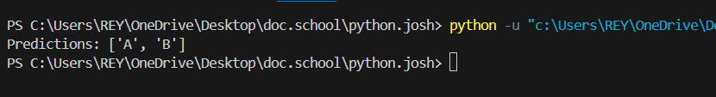

KNN ALGO SCREENSHOT